Having trouble downloading Pcard forms?

WSU employees who connect to the Internet through firewalls and from non-wsu.edu domains may have difficulty accessing PDF forms from the Business Policy & Procedure Manual. To overcome this difficulty, do the following:

- Verify you have Adobe Acrobat Reader installed on your computer

- Go to http://www.wsu.edu/forms2/index.cgi

- Sign in with a WSU Network ID and password

- Scroll to the PDF Version Manuals (Alternate Access):

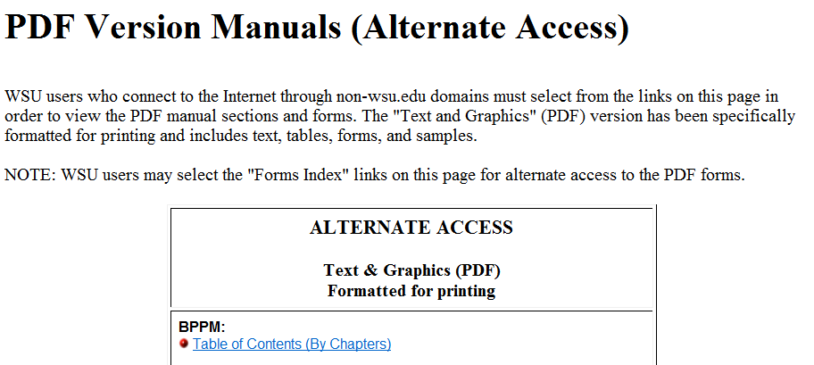

- Click on BPPM “Table of contents (By Chapters)” and click on the Chapter 70 link box

- Scroll to Section 70.08 where the Pcard forms are found.
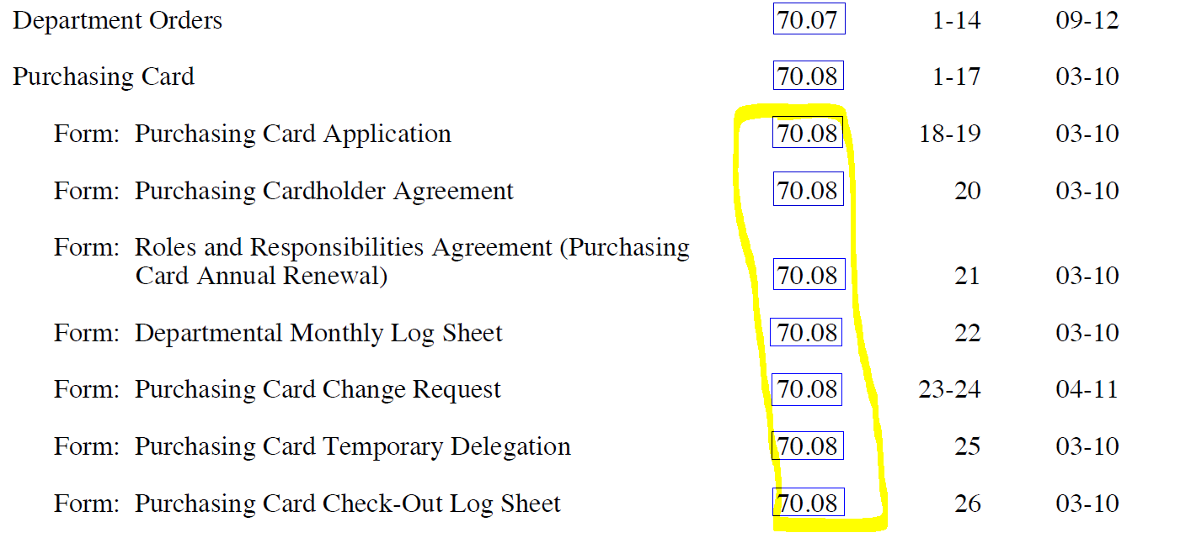

- Select the form you need by clicking on the adjacent 70.08 link box

If this alternative access method fails for you, email prf@wsu.edu or call 509-335-2005 for assistance.

